

A

PROJECT REPORT ON BAKERY MANAGEMENT SYSTEM S.Y.B.B.A(CA)(SEM-IV) 2023-2024 SUBMITTED TO SAVITRIBAI PHULE

PUNE UNIVERSITY DEVELOPED BY Buddhivant Tejas Ganesh

UNDER GUIDENCE OF Prof.ASHA MANE

**Department :-BBA(CA)**

**ANNASAHEB MAGAR COLLEGE, HADAPSAR, PUNE-411028**



ANNASAHEB MAGAR COLLEGE, HADAPSAR, PUNE-411028 DEPARTMENT OF BBA(CA) CERTIFICATE

This Is Certify That Buddhivant Tejas Ganesh Student of **Bachelor Business Administration (Computer Application)**Has Satisfactory Completed the Project Work In **“Bakery management System”** As Per the Syllabus Laid Down by The **Savitribai Phule Pune University** During the Academic Year **2023-2024**.

Date: -

|  |  |
| --- | --- |
| Exam Seat No: - | Exam Seat No: - |
| Project In Charge | Head of Department |
| Internal Examiner | External Examiner |

**Acknowledgement**

In Successfully Completing This Project, Many People Have Helped Us. I Would Like to Thank All Those Who Are Related to This Project.

Primarily, I Would Thank God for Being Able to Complete This Project with Success. Then I Will Thank Prof.Asha Mane , Under Whose Guidance I Learned a Lot About This Project. His Suggestions and Directions Have Helped in The Completion of This

Project.

Finally, I Would Like to Thank My Parents and Friends Who Have Helped Me with Their Valuable Suggestions and Guidance and Have Been Very Helpful in Various Stages of Project Completion.

**Submitted by**

Buddhivant Tejas Ganesh

**Index**

|  |  |  |
| --- | --- | --- |
| **Chapter No.** | **Particular Name** | **Page no.** |
| **1.** | **Introduction: -** | 5 |
|  | 1.1 Existing System | 7 |
|  | 1.2 Scope Of System | 8 |
|  | 1.3 Purpose of The System | 9 |
| **2.** | **System Analysis: -** | 11 |
|  | 2.1 Feasibility Study | 12 |
|  | 2.2 Fact Finding Technique | 14 |
|  | 2.3 Hardware and Software Requirement | 18 |
| **3.** | **System Design: -** | 20 |
|  | 3.1Entity Relationship Diagram | 21 |
|  | 3.2 Data Flow Diagram | 22 |
|  | 3.3 File Design | 25 |
|  | 3.5 Data Dictionary | 27 |
| **4** | **Forms And Report** | 30 |
| **5** | **Testing** | 35 |
| **6** | **Advantages & Disadvantages** | 37 |
| **7** | **Conclusion** | 38 |
| **8** | **Future Enhancement** | 40 |
| **9** | **References** | 41 |

# Introduction

“Welcome to our online cake Shoppe for those who can Enhancing Sweet Experiences

In the dynamic realm of e-commerce, the establishment of an online cake shop stands as a testament to the fusion of culinary artistry, technological innovation, and consumer convenience. This project aims to delve into the conceptualization, development, and operational aspects of a virtual bakery - the "Online Cake Shoppe".

* But our project is more than just an exercise in coding – it's a journey of innovation and learning. Throughout the development process, we have tackled challenges, honed our skills, and pushed the boundaries of what's possible in the world of online commerce.
* It has a user-friendly interface and customizable forms that can be adapted to different contexts and languages.
* It has a robust security system that ensures data privacy and confidentiality.

# Existing System

* 1. The existing system of an online cake bakery for a college project typically encompasses a well-structured digital platform accessible through a website or mobile application. This platform serves as the central hub for customers to explore a diverse array of cakes, pastries, and desserts, each presented with detailed descriptions and visual representations. Upon selecting their desired items, customers proceed to place orders through an intuitive ordering system, which securely processes payments and generates order confirmations. Behind the scenes, the bakery's production team follows a streamlined workflow to fulfill orders, from sourcing ingredients to baking, decorating, and packaging. Logistics play a crucial role in coordinating timely deliveries, often involving partnerships with third-party delivery services or in-house fleet management. Throughout the entire process, effective communication channels are maintained to keep customers informed about their order status and to address any inquiries or concerns promptly. Payment processing is seamlessly integrated, offering various payment options to accommodate different preferences.
  2. **Scope of system**

The scope of an online cake shop system is multifaceted, encompassing a comprehensive range of functionalities and services. Primarily, it involves the provision of an extensive selection of cakes, desserts, and baked goods, coupled with the ability to customize orders based on individual preferences, flavours, and occasions. From a technological standpoint, the scope extends to the development of a user-friendly e-commerce platform, ensuring an intuitive interface for customers to browse, select, and purchase products seamlessly. This encompasses robust systems for order management, secure payment gateways, and efficient inventory control to maintain adequate stock levels and meet customer demand. Furthermore, the scope extends to logistics and delivery services, encompassing partnerships with shipping providers or in-house delivery systems to ensure timely and reliable delivery to customers' doorsteps.

* 1. **Purpose Of The System**

The purpose of the online cake bakery system is multifaceted, aiming to fulfill the needs of both the bakery and its customers. Here are the primary purposes of the system:

1. **Enable Online Ordering**: The system allows customers to conveniently browse through a catalog of cakes and desserts, customize their orders, and place them online from anywhere at any time.
2. **Streamline Operations**: By automating the ordering process and integrating various backend functionalities such as inventory management, production scheduling, and delivery logistics, the system helps streamline the bakery's operations, reducing manual errors and optimizing efficiency.
3. **Enhance Customer Experience**: The system is designed to provide customers with a seamless and enjoyable shopping experience, offering a user-friendly interface, detailed product information, secure payment options, and transparent communication throughout the ordering and delivery process.
4. **Expand Market Reach**: By establishing an online presence, the bakery can reach a broader audience beyond its physical location, attracting customers from different geographic areas and expanding its market reach.

# System Analysis

* 1. **Feasibility Study**

A technical feasibility study and an economic feasibility study are two important aspects of a feasibility study for a child day care management system. A technical feasibility study evaluates whether the system can be developed and implemented using the available technology, resources and skills. An economic feasibility study evaluates whether the system is financially viable and sustainable. Here are some of the steps involved in conducting these studies:

**Technicalfeasibilitystudy**

Define the scope and objectives of the system, such as the features, functions, requirements and specifications.Identify the hardware and software requirements for the system, such as the devices, platforms, applications, databases, etc.Assess the availability and adequacy of the technical resources and skills needed to develop and maintain the system, such as the developers, testers, administrators, etc.Evaluate the compatibility, reliability, security and maintenance of the system, such as how it will integrate with the existing systems and processes, how it will ensure data quality, privacy and protection, how it will handle errors, failures and contingencies, etc.Test and prototype the system to measure its functionality and performance, such as how it will meet the user needs and expectations.

**Economical feasibility study:**

Estimate the initial and recurring costs of developing and operating the system, such as the capital expenditure, operational expenditure, maintenance expenditure, etc.Forecast the expected revenues and savings from using the system, such as the income generation, cost reduction, efficiency improvement, etc.Analyze the non-monetary benefits and costs of using the system, such as the customer satisfaction, employee engagement, social impact, environmental impact, etc.Calculate the return on investment (ROI), break-even point (BEP) and payback period (PP) of the system, such as how much profit or loss it will generate over a period of time, how long it will take to recover the investment in the system, etc.Compare different alternatives and scenarios to determine the optimal solution for the system, such as how it will perform under different

assumptions and variables, how it will rank against other options or competitors, how it will align with the strategic goals and priorities of the organization, etc.

**Operational feasibility study-**

An operational feasibility study is a process of evaluating how well a proposed system or solution will work in the existing organizational environment. It considers the human, social and

organizational factors that may affect the success and acceptance of the system or solution To conduct an operational feasibility study for Bakery management system, one can use various sources of information, such as:

# Fact-Finding Technique

A database developer commonly uses several fact-finding techniques during a single database project. There are five widely used fact-finding techniques:

Various fact finding techniques were used to collect detailed information about each and every aspect of the BAKERY MANAGEMENT SYSTEM following fact finding techniques were adopted.

⦁ Fact finding technique is the formal process of using research, interviews, questionnaires, and preferences.

⦁ It is also called data collection.

⦁ INTERVIEW

Timely discussions with concerned person were made to understand the exact requirement of the system .These discussions were also useful in bringing up new ideas as to make system more effective. This technique is used to collect information from individuals or from groups. Through such invaluable techniques, it is possible to find much of the quality information and also some option and underlying problems.

⦁ SURVEYS :

Surveys of the online cake bakery system provide valuable insights into customer satisfaction, preferences, and areas for improvement. Through targeted surveys distributed to customers post-order or via email, the bakery can gauge overall satisfaction levels, assess the quality of products and services, and gather feedback on specific aspects such as website usability, delivery experience, and product variety.

⦁ OBSERVATION :

The first hand information about various activities that are carried out can be studied through observation of general procedures. The information about company is stores in database. As analyst this technique showed us many missed facts. We also found some new ways to improve existing manual procedure.

⦁ Focus groups :

Focus groups can be used to gather feedback from a group of stakeholders in a structured setting. Focus groups can be conducted in-person or online and can be used to gather feedback on online Bakery experience.

· **Questionnaire**

1. **Overall Experience**
   * On a scale of 1 to 5, how would you rate your overall experience with our online cake bakery system?
   * What aspects of your experience were most satisfying?
2. **Ordering Process**
   * How easy was it to navigate through our website/app and place your order?
   * Did you encounter any difficulties during the ordering process? If so, please specify.
3. **Product Quality**
   * Were you satisfied with the quality of the cake/desserts you received?
   * Did the products meet your expectations in terms of taste, freshness, and presentation?
4. **Delivery Experience**
   * How satisfied were you with the timeliness and accuracy of the delivery?
   * Were the products delivered in good condition?
5. **Customer Service**
   * Did you have any interactions with our customer service team? If yes, how would you rate the level of assistance provided?
   * Were your inquiries or concerns addressed satisfactorily?
   1. **Hardware & Software RequirementHardware Requirement:**

RAM: - 8 GB Ram For Server

Hardware: - 512 GB Hardware Server Data

**Software Requirement: - Front End**

* HTML
* CSS
* Javascript

**Back End**

· PHP

* MySQL Server (Back-End)

**Operation Performed**

* Web Browser: Microsoft Internet Explorer, Mozilla, Google Chromeor Later
* Operating System : Windows 11

# System Design

* 1. **Entity Relationship Diagram**

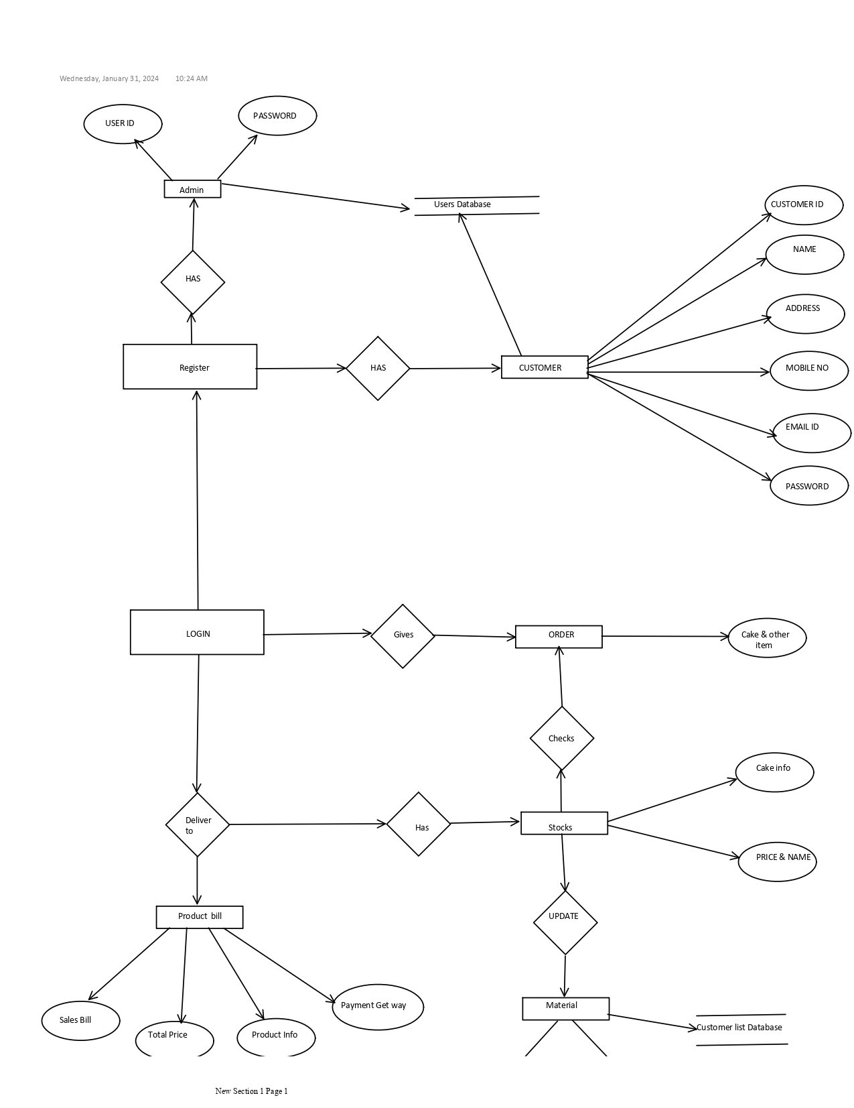

* 1. **Data Flow Diagram :-**

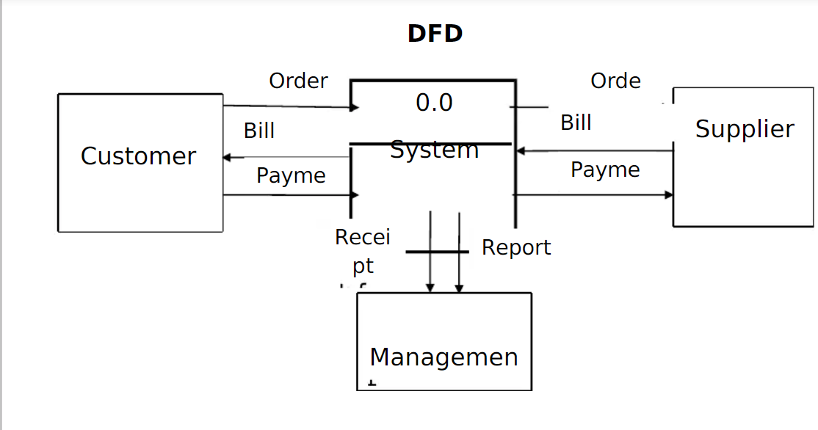

**First Level DFD :-**

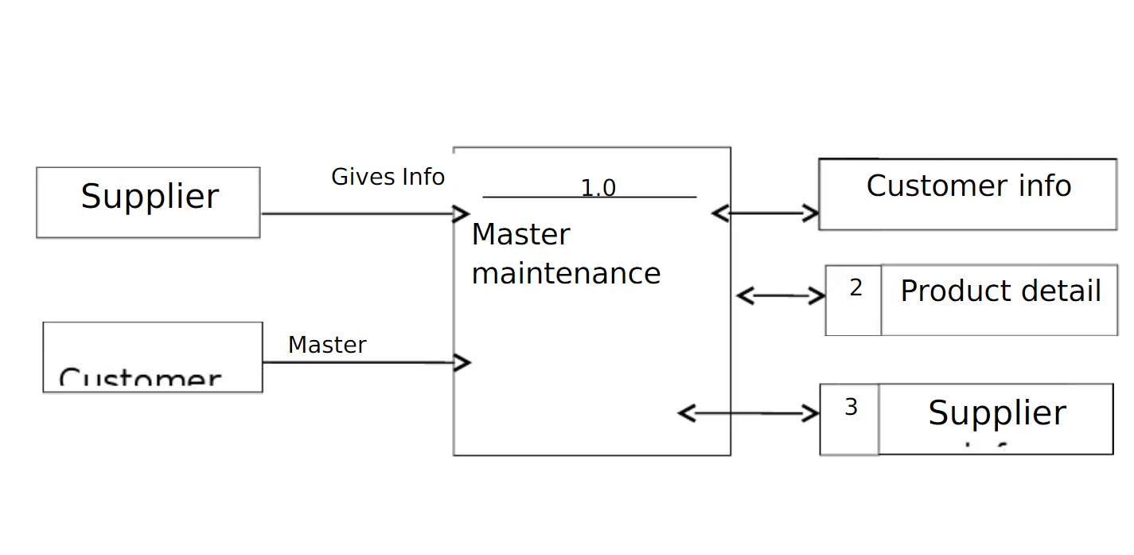

# File Design

* + - **Admin Login :-**

|  |  |  |
| --- | --- | --- |
| **Fields Name** | **Data type** | **constraints** |
| username | varchar(255) | - |
| Password | varchar(255) |  |
| Sr no | Int (100) |  |
|  | | |

* + - **System Info :-**

|  |  |  |
| --- | --- | --- |
| **Fields Name** | **Data type** | **constraints** |
| ID | int(11) | - |
| meta_field | Text | - |
| meta_value | Text | - |

* + - **Customer Info:-**

|  |  |  |
| --- | --- | --- |
| **Fields Name** | **Data type** | **constraints** |
| ID | int(50) | Primary |
| First name | varchar(250) | - |

|  |  |  |
| --- | --- | --- |
| Username | Text | - |
| Password | Text | - |
| Address | Text | - |
| data created | data time | - |

· **Payment Details:-**

|  |  |  |
| --- | --- | --- |
| **Field Name** | **Data Type** | **Constraints** |
| id | Integer | Primary key |
| Name | Varchar | **-** |

* 1. **Data Dictionary**

|  |  |  |  |  |
| --- | --- | --- | --- | --- |
| **Fields Name** | **Fields** | **Data type & Data Size** | **constraints** | **Table Name** |
| user | fullName | varchar(255) | Index | Admin_login |
|  | username | varchar(255) | - |  |
|  | Password | varchar(255) |  |  |
|  | address | text |  |  |
|  | email | text |  |  |
|  | Mobil no | Int(10) |  |  |
| Customer  _list | ID | int(30) | Primary | Customer_list |
|  | Cake name | text |  |  |
|  | Full Name | varchar(100) | - |  |
|  | Address | text |  |  |
|  | email | text |  |  |
|  | Mobile no | Int (10) |  |  |
|  | data updated | data time | - |  |

· **Form Design**

**Public Home Page**

Our Bakery Management System pages:

* + Admin
  + Customer
  + Buying
  + Sign in
  + About Us

**Public Home Page**

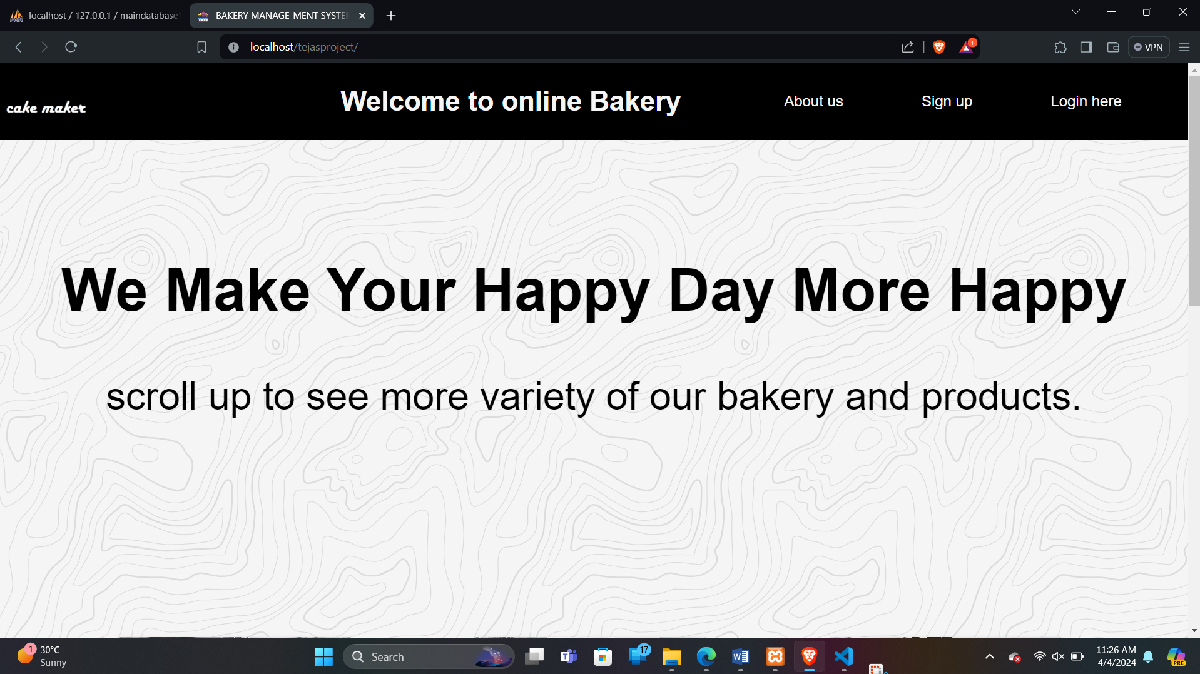

Our Bakery Management System pages:

* + Admin
  + Customer
  + Destination
* **Users / Admin Page**

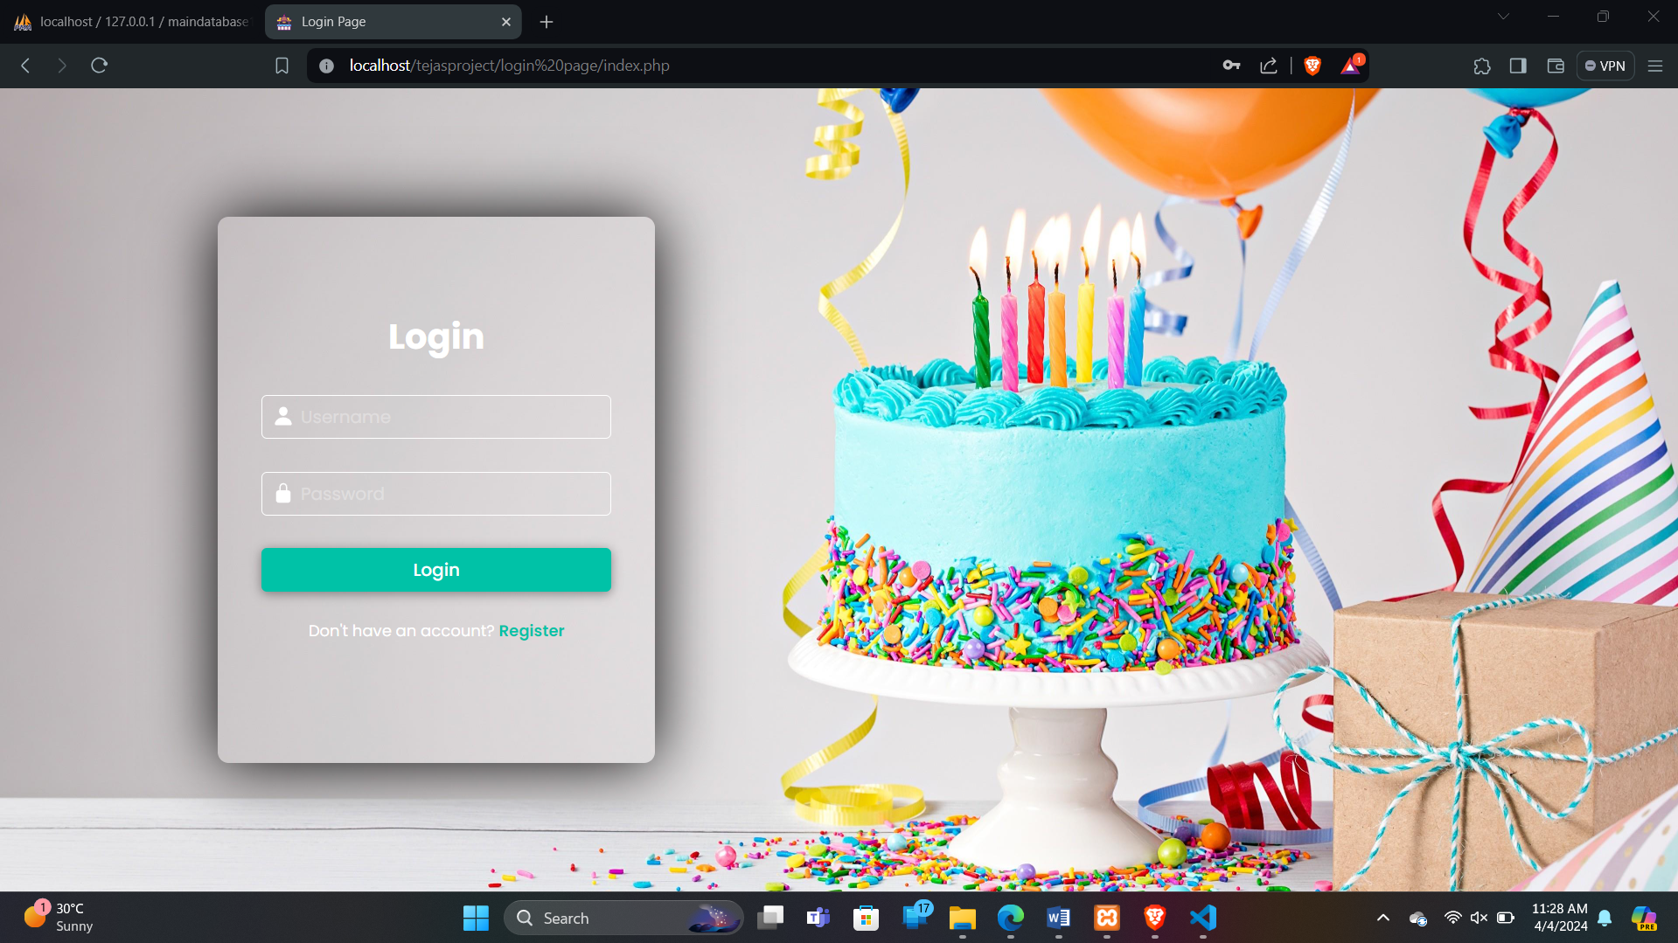

**Customerlist :-**

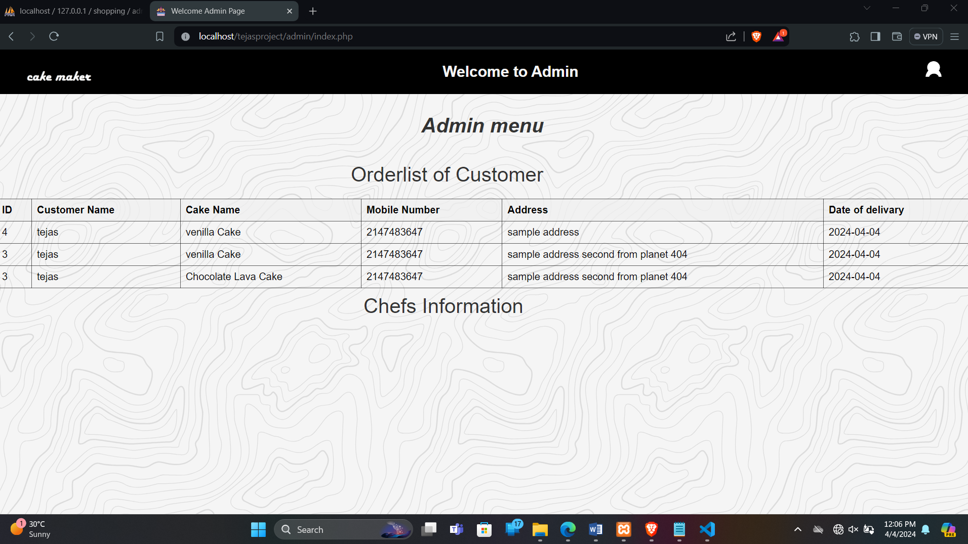

**Destination:-**

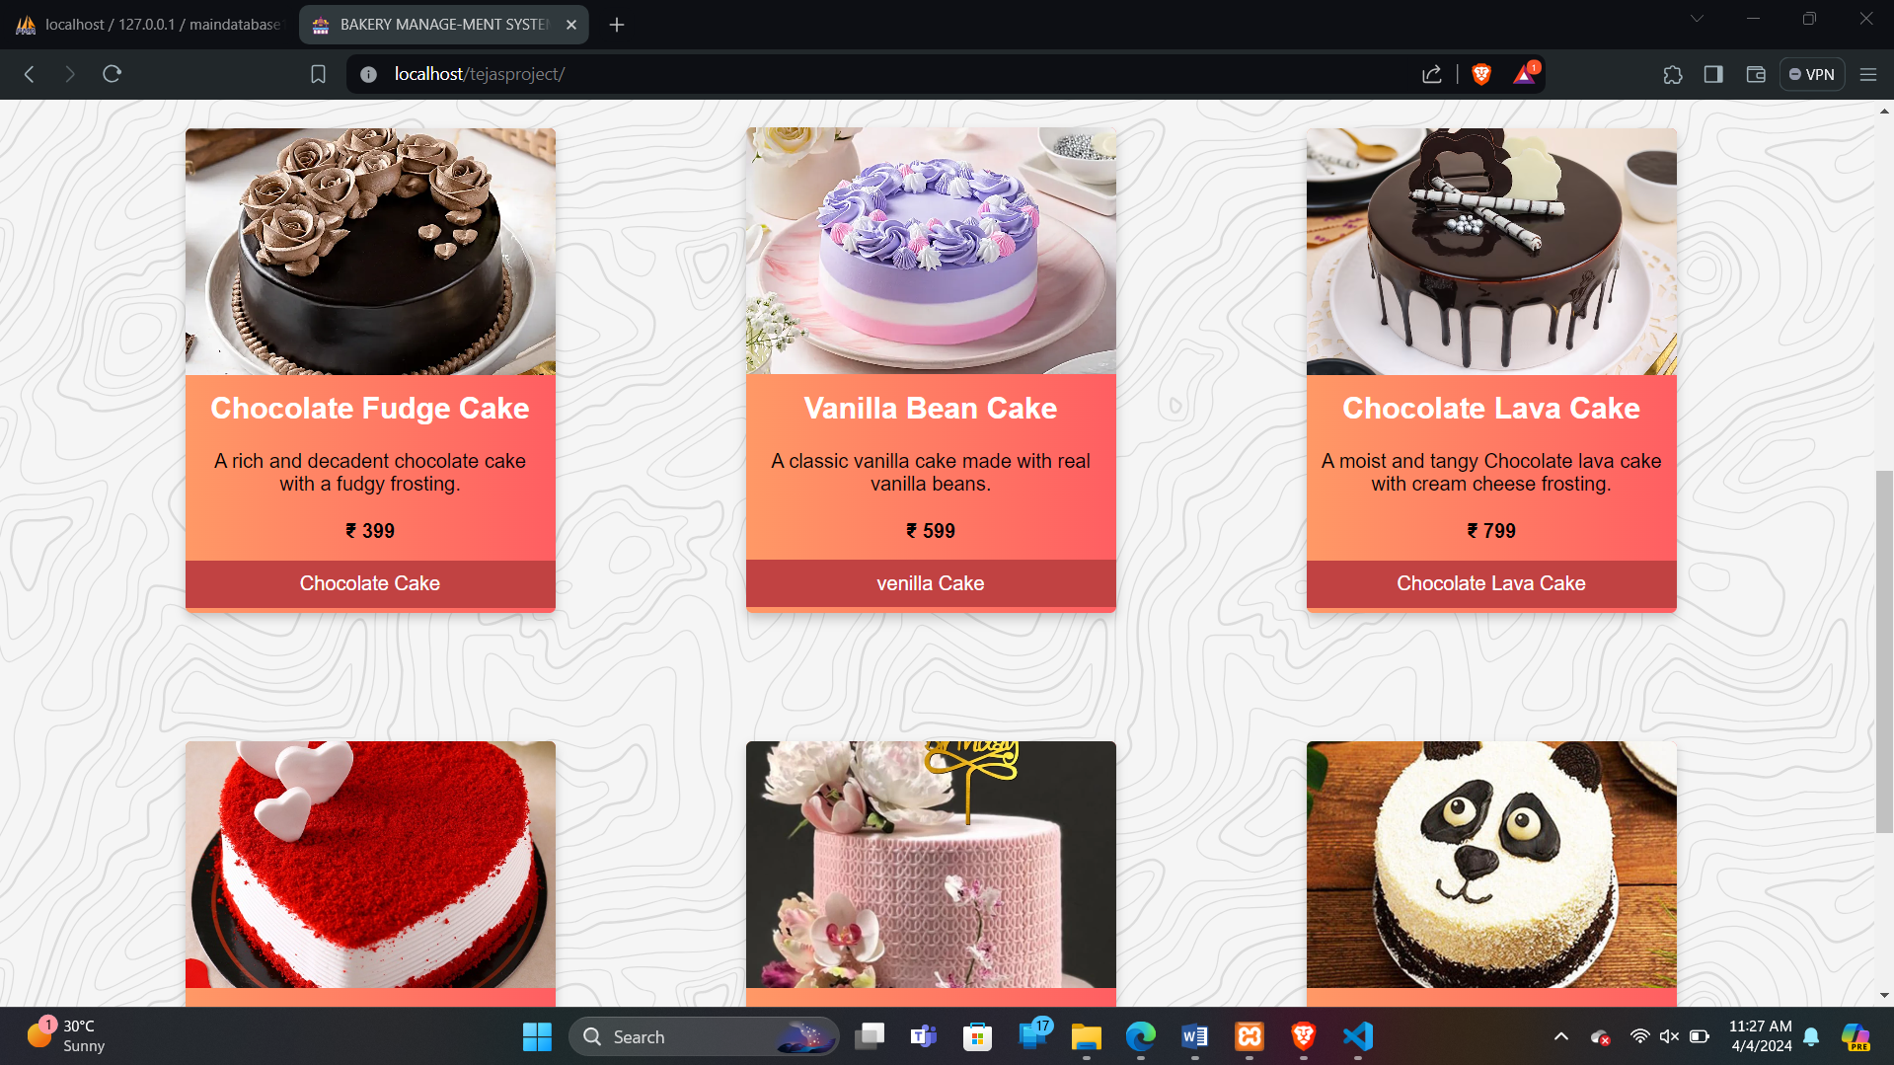

**Customer login**



* **Booking Form**

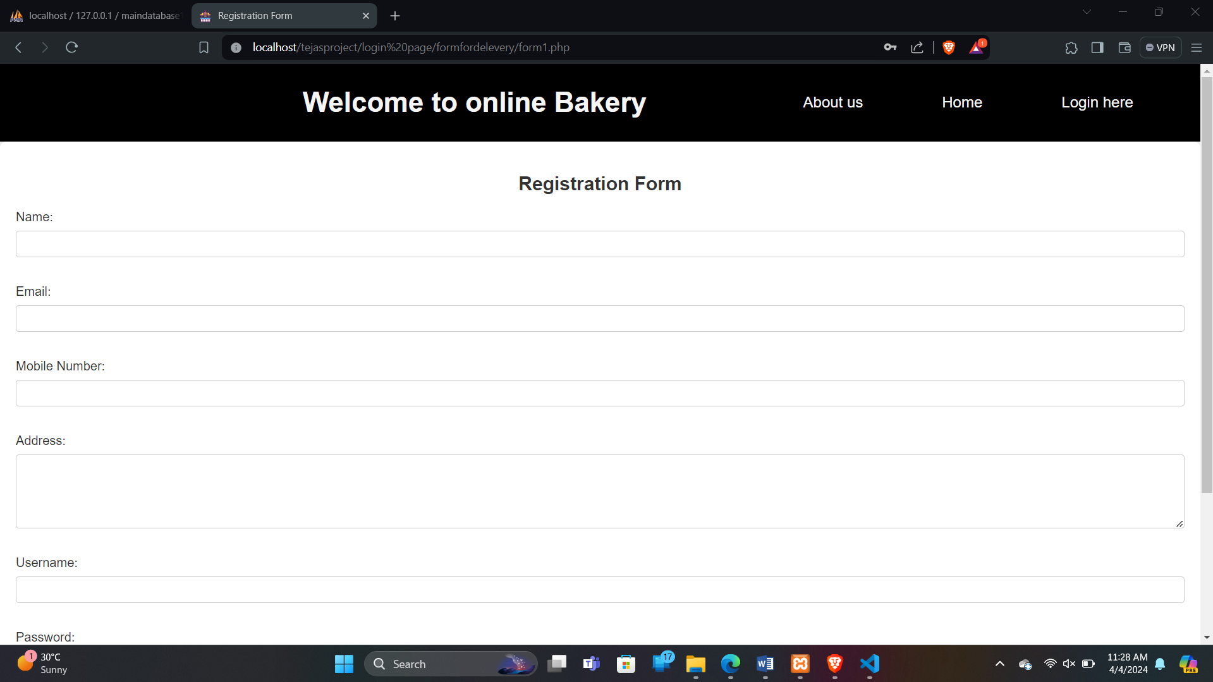

**•Bill info:**

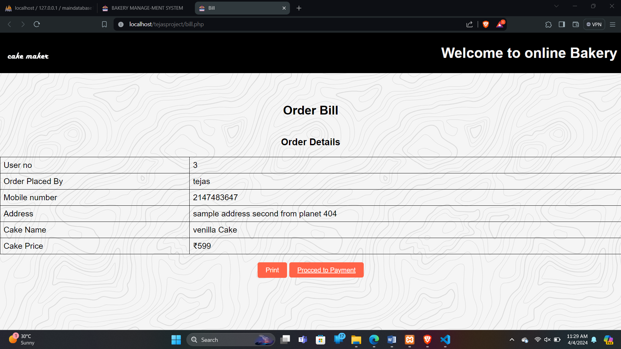

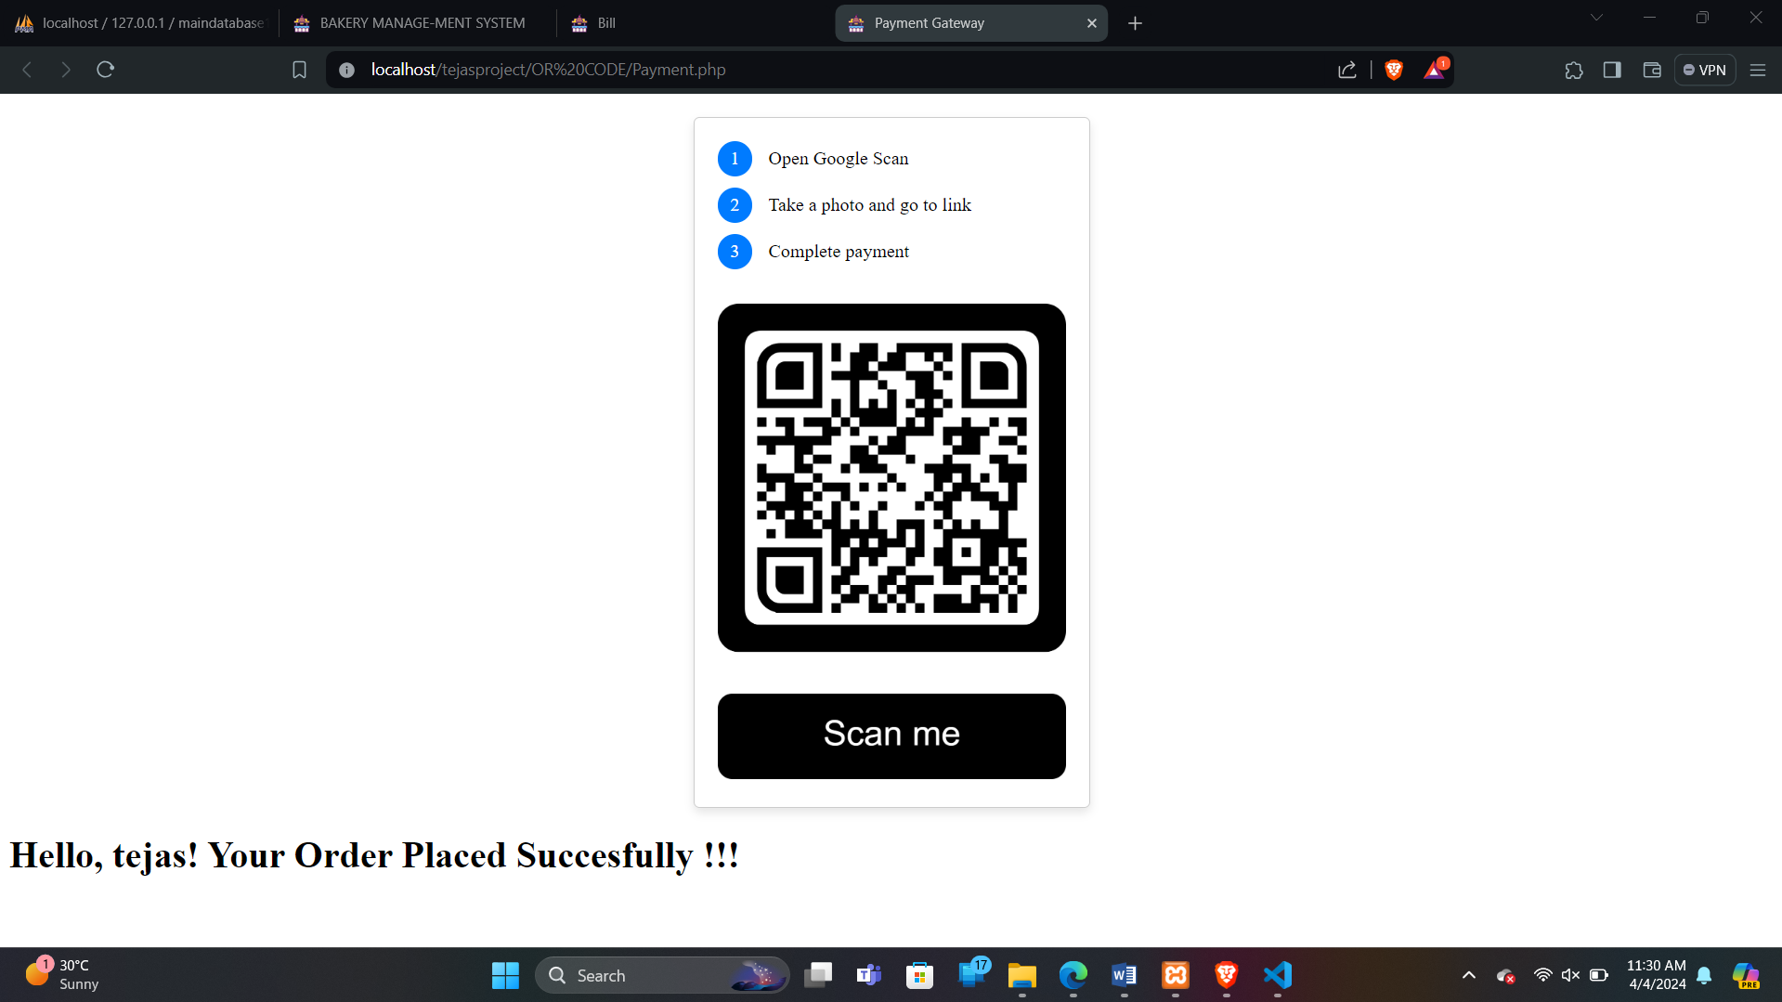

**1Testing**

* **Black Box Testing**

The end user has concluded Black Box Testing. The user is most concerned with the inputs that the system accepted and the output that if generated.

Using this approach, it is useful in finding the incorrect or missing function interface errors, errors in database, initialization and termination errors. The user has checked every GUI error

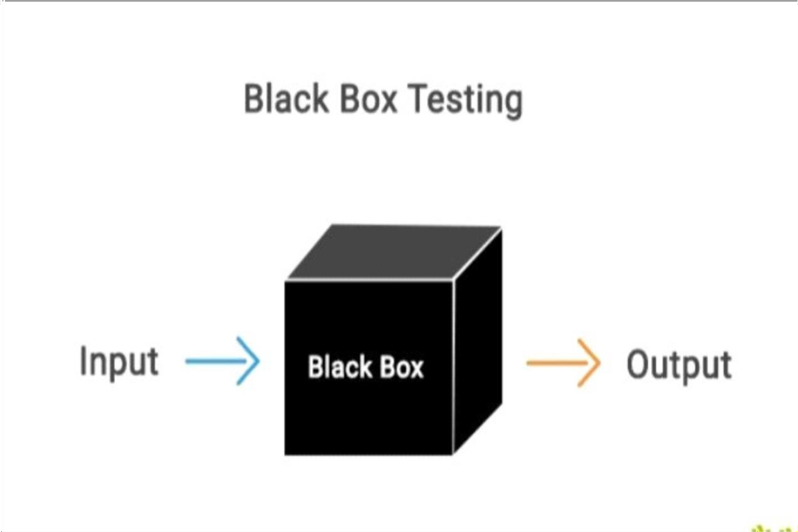and report for error.

* **System Testing:-** Software and hardware are integrated and fill ranges of system tests are conducted in an attempt to uncover the error at the software and hardware interface. The backend connectivity (IDLE DB) was checked.
* **Integration Testing:-** The Integration testing is also used to test between the different stages of the project. The entire program was tested as a whole.
* **Load Testing:-** The system was tested with load testing. The records were added to the system till filled. The total numbers of transactions are considered as maximum load for the system speed an be compromised.
* **Stress Testing:-** Stress testing ensures that a system can process its intended workload
* loading is steadily -increased till the system fails.
* **Module Testing:-** Each module was tested for its functionality. The validations were tested in this approach.

**White Box Testing**

White-box testing (also known as clear box testing, glass box testing, transparent box testing, and structural testing) is a method of testing software that tests internal structures or workings of an application, as opposed to its functionality (i.e., black-box testing). In white-box testing an internal perspective of the system, as well as programming skills, are used to design test cases. The tester

chooses inputs to exercise paths through the code and determine the appropriate outputs. This is analogous to testing nodes in a circuit, e.g., in-circuit testing (ICT). White-box testing can be applied at the unit, integration and system levels of the software testing process. Although traditional testers tended to think of white-box testing as being done at the unit level, it is used for integration and system testing more frequently today. It can test paths within a unit, paths between units during integration, and between subsystems during a system–level test. Though this method of test design can uncover many errors or problems, it has the potential to miss unimplemented parts of the specification or missing requirement.

* + **Advantages & Limitation**
* **Advantages**
* · High Security and Reliability.
* · Less Man-work
* · Portable Mobile Access with Easy Accessibility
* · Save Time while generating receipts
* · Track day-to-day activities and scheduled programs
* · Share test schedules , timings as well as results
* · Customize Meal Plans and Program
* The transactions are executed in off-line mode, hence data for Bakery, sales capture and modification is not possible.
* Off-line reports of cakes, orders, products cannot be generated due to batch mode execution.
* The existing system only provides text-based interface, which is not as user-friendly as Graphical user Interface.
* **Disadvantages**
* Risk of data leaks (in case of free or unreliable applications)
* Complicated applications are hard to understand
* Bugs can effect performance of application
* No access in absence of network

· **Conclusion**

The development of Bakery management system involved many phases. The approach used is a top- down one concentrating on what first then how and moving to successive levels of details .

The first phase started with a detailed study of the problems and prospects of ordering in cakes.

This software is efficient in maintaining customer’s details and can easily perform operations on platform.

* **Future Enhancement**
* In the future we will create more reliable long databases for fetching records. We will also try to provide best services and also online payment methods.
* In future we will try to updated customer profile and also admin profile . Some more interesting features will be added so that customer will find it as more useful .
* **References**
* Code Complete By:- Tejas Ganesh Buddhivant
* Test Driven Development By:- Tejas Ganesh Buddhivant
* Archer, B. H. (1982). The Value of Multipliers and Their Policy Implications.

*Bakery management system, 3*(4), 236-241.

* **WEBSITES: 002D**
* [WWW.GOOGLE.COM](http://www.google.com/)
* [WWW.YOUTUBE.COM](http://www.youtube.com/)
* [https://www.javatpoint.com](https://www.javatpoint.com/)
* <https://www.w3schools.org/>
* https://www.chatgpt.com